QUASI-FROZEN SPIN CONCEPT OF MAGNETO-OPTICAL STRUCTURE OF NICA ADAPTED TO STUDY THE ELECTRIC DIPOLE MOMENT OF THE DEUTERON AND TO SEARCH FOR THE AXION

Y. Senichev, A. Aksentyev, S. Kolokolchikov, A. Melnikov, Institute for Nuclear Research of Russian Academy of Sciences, Moscow, Russia   
V. Ladygin, E. Syresin, Joint Institute for Nuclear Research, Dubna, Russia  
 N. Nikolaev, Landau Institute of Theoretical Physics, Chernogolovka, Russia

Abstract

The "frozen spin" method is based on the idea that at certain parameters of the ring, the particle spin rotates with the frequency of the momentum, creating conditions for the continuous growth of the electric dipole moment signal. Since a straightforward implementation of the frozen spin regime at NICA is not possible, we suggest an alternative quasi-frozen spin approach concept. In this new regime, the spin oscillates about particle orbit with the spin phase advance $π⋅γG/2$, locally recovering the longitudinal orientation at the location of the electric-magnetic Wien filters in the straight sections. In the case of deuterons, thanks to the small magnetic anomaly G, the spin continuously oscillates relative to the direction of the momentum with a small amplitude of a few degrees and the expected EDM effect is reduced only by a few percent. In this paper, we study the spin-orbital motion with the aim of using the NICA collider to measure the EDM. We also comment on the potential of NICA as an axion antenna in both the quasi-frozen spin regime and beyond.

”frozen spin” concept

The idea of searching for the electric dipole moment (EDM) of the proton and the deuteron using polarized beams in a storage ring is based on the “frozen spin” method and was originally proposed at Brookhaven National Laboratory (BNL) [1]. The concept of the “frozen spin” (FS) lattice consists of deflectors with electric and magnetic fields incorporated in one element, in which the spin vector of the reference particle is always orientated along the momentum. This is clearly evident from the Thomas–Bargmann–Michel–Telegdi equation: is possible:

$$\frac{d\overset{→}{S}}{dt}=\overset{→}{S}×\left({\overset{→}{Ω}}_{mdm}+{\overset{→}{Ω}}_{edm}\right);$$

$${\overset{→}{Ω}}_{mdm}=\frac{e}{mγ}\left\{\left(γG+1\right)-\left(γG+\frac{γ}{γ+1}\right)\frac{\overset{→}{β}×\overset{→}{E}}{c}\right\}$$

${\overset{→}{Ω}}_{edm}=\frac{eη}{2m}\left(\overset{→}{β}×\overset{→}{B}+\frac{\overset{→}{E}}{c}\right);G=\frac{g-2}{2}$ (1)

where $G$ is the magnetic anomaly, $g$ is the gyromagnetic ratio, $Ω_{mdm}$ is the spin precession frequency due to the magnetic dipole moment, $Ω_{edm}$ is the spin precession frequency due to the electrical dipole moment, and $η$ is the dimensionless coefficient defined in (1) by the relation $d=ηeℏ/4mc$. The advantages of purely electrostatic machines are especially evident at the “magic” energy, when angle :

$G-1/\left(γ_{mag}^{2}-1\right)=0$, (2)

and the spin vector initially oriented in the longitudinal direction rotates in the horizontal plane with the same frequency as the momentum $Ω_{p}$, i.e., $Ω_{mdm}-Ω_{p}=0$.

In the case of deuterons with $G=-0.142$ the only possible method is a hybrid storage ring with both electric and magnetic fields [2]. This can be done by applying a radial electric field $E_{r}$ to balance the vertical magnetic field $B_{v}$ contribution to $Ω_{mdm}^{p}$, as shown in Eq. (1):

$E_{r}=\frac{GBcβγ^{2}}{1-Gβ^{2}}≈GB_{v}cβγ^{2}$. (3)

Thus, the only requirement of the “frozen” spin condition is to maximize the EDM signal growth. For both protons and deuterons there is a general idea of how to construct a ring, but this is realized with the help of different types of deflectors.

”quasi-frozen spin” concept

In the NICA ring, the implementation of the FS concept would require a complete upgrade of the optics.

However, suppose the spin would oscillate in the horizontal plane with respect to the frozen spin direction with small amplitude of angle ${\left(Φ_{s}\right)}^{2}≪1$. This could be done by placing special, electric-field elements in the straight accelerator sections, which would bring the spin vector back in alignment with the momentum after it moved away from it in the magnetic arc. Then the EDM growth would decrease proportionally to the factor $J_{0}(Φ_{s})≈1-{\left(Φ_{s}\right)}^{2}/4$. Since the deuteron’s magnetic anomaly $G=-0142$ has a small value and since, in the imagined case, the spin oscillates around the momentum direction within a half value of the advanced spin phase in the magnetic arc $Φ_{s}=π⋅γG/2≈0.2$, it is obvious that the effective contribution to the expected EDM effect is reduced by only a few percent at the optimal parameters for the EDM measurement $γ=1.12$.

The mental experiment described above gives the gist of the “quasi-frozen” spin (QFS) concept [3]: here the spin is not frozen with respect to the momentum vector, but continually oscillates around some average fixed direction coinciding with the momentum direction. Next, we have to answer the question of how to implement a variable MDM spin precession in the storage ring (which is needed for its zero-averaging in statistics) and to provide a sufficient EDM signal growth.

In the case of the “quasi-frozen” structure, there are two options. In the first QFS version the magnetic and electric fields are completely spatially separated: the former is found in the magnetic arcs and the latter in the straight sections, which are realized in the form of negative-curvature “reverse electric” arcs, respectively [4]. However, this lattice design concept inherits the “cylindrical electrodes” drawback, namely, a whole set of high-order field nonlinearities. Therefore, in the second version of the QFS lattice, we introduced a small magnetic field ~100 mT into the spin-aligning (E+B) elements, which compensates for the Lorentz force of the electric field and allows us to make them straight.

Since the second option is the most appropriate for a ring undedicated to an EDM search, we will only discuss this option here.

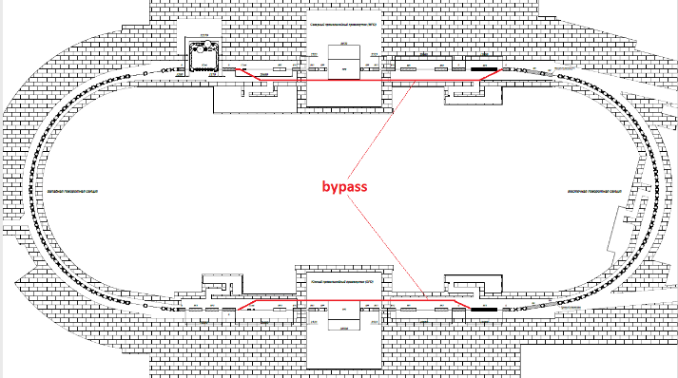So, first we determine the rotation of the spin relative to the momentum direction in the magnetic arcs. In the magnetic arc, the momentum of particles is rotated by angle $Φ_{arc}^{B}=π$, with a simultaneous MDM spin rotation in the horizontal plane relative to the momentum by an angle:

$Φ_{s}^{arc}=γG⋅Φ_{arc}^{B}$. (4)

In the E+B elements of the straight section, the spin-rotation due to the MDM occurs in the horizontal plane and is constituted by two components: respectively in the E- and B-fields. In the E-field it occurs in the direction opposite to the momentum rotation by an angle:

$Φ_{s}^{E}=-\left(γG+\frac{γ}{γ+1}\right)β^{2}⋅Φ_{ss}^{E}$, (5)

where $Φ_{ss}^{E}$ is the momentum rotation in the electric field, and in the B-field in the same direction by angle $Φ_{s}^{B}=(γG+1)⋅Φ_{ss}^{B}$, where $Φ_{ss}^{B}$ is the momentum rotation in magnetic field. Since the Lorenz force is zero, the momentum rotation angles $Φ_{ss}^{E}=Φ_{ss}^{B}$ are equal, and we can express both components of the spin-rotation through one of them, for instance, through the magnetic field rotation $Φ_{ss}^{B}=\frac{eB_{ss}}{mγv}⋅L_{ss}$, where $B_{ss},L_{ss}$ are the magnetic field and the length of the straight element, respectively. To realize the QFS concept, we have to fulfill the “QFS condition” $Φ_{ss}^{B}-Φ_{ss}^{E}=Φ_{arc}^{B}$, i.e.:

$(γG+1)⋅Φ_{ss}^{B}-\left(γG+\frac{γ}{γ+1}\right)β^{2}⋅Φ_{ss}^{E}=γG⋅π$ (6)

Carrying out simple transformations, we obtain the definitions of the E+B element parameters:

$L_{Σ}E_{ss}=\frac{G}{G+1}⋅\frac{mc^{2}}{e}⋅πβ^{2}γ^{3}$ and $B_{ss}=-\frac{E_{ss}}{cβ}$, (7)

where $L_{Σ}$ is the total length of the set of straight elements in one straight section.

Thus, taking a more or less realistic value of the electric field at the level of 100 kV/cm, the corresponding magnetic field is below 96 mT. This opens up prospects for simplifying the technical construction. In particular, a permanent magnet or an air core electric coil may be used.

UPgraded optical structure of NICA for the edm search

The NICA structure was not designed with the electric dipole moment research in mind, and hence our only option is to resort to the “quasi-frozen spin” concept. It is obvious that this can be done for deuterons.

The adaptation strategy for the NICA collider structure to the EDM search was based on two circumstances. The first is that the straight sections of the collider are completely occupied by equipment for experiments using the MPD and SPD detectors, and the second is that these detectors and meeting points are inconsequential for the EDM search. The simplest solution in this case is to introduce bypasses as shown in Fig. 1.

Figure 1: Upgraded lattice of NICA for the EDM search with bypass insertions (red color).

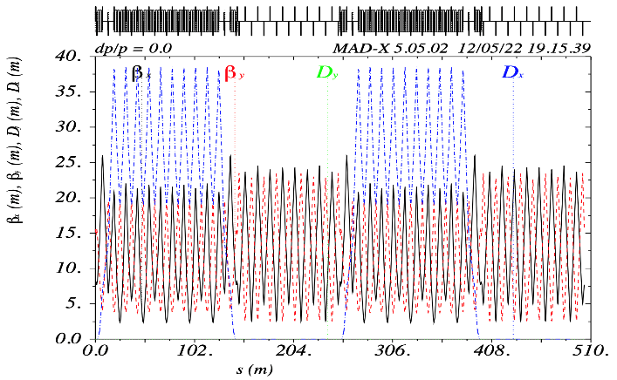The bypass sections do not include both detector’s interaction points and are free to accommodate E+B elements. Without the interaction points, we have two uncoupled rings, with a possibility of doubling the statistics-collection rate.

Figure 2: Twiss parameters of NICA with bypass insertion.

The latter are transparent to the beam dynamics (due to the zero Lorentz force) and rotate the spin in the direction opposite to the rotation the arc, thus realizing the quasi-frozen spin concept.

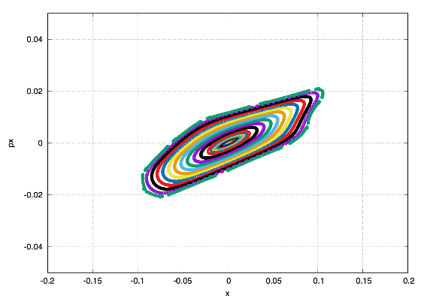In Fig. 2 and Fig. 3 we show the Twiss functions and the dynamic aperture for the both transverse planes. As one can see, the linear part of the dynamic aperture of $\sim$ 2000 mm mrad significantly exceeds the required value in both planes. Taking into account the limiting values of the electric field $\sim 100kV/cm$ and using the obtained expressions for the E+B element parameters, one computes their required net length for one bypass section of $\sim$ 25-30 meters, which is 30% of the total length of the bypass section.

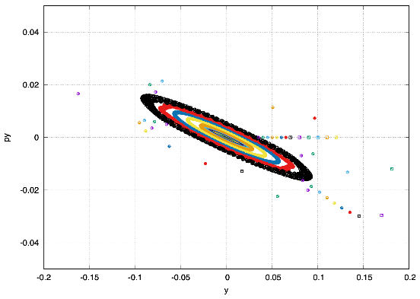a) horizontal plane

b) vertical plane

Figure 3: Dynamic aperture in both planes for NICA with bypass.

Figure 3.tifFig. 4 shows the result of spin-orbit tracking along the ring. By the value of the horizontal projection of the spin, we see how the spin changes direction with respect to the momentum.

Figure 4: Transverse $S_{x}$ component vs turn number.

Despite a change of direction within 10 degrees, the polarization asymmetry remains constant at the location of the polarimeter.

search for axion at the nica

Peccei-Quinn axions, suggested as a solution to the strong CP-problem, are viewed as one of the most credible candidates for the dark matter. Spin of particles couples to the oscillating pseudomagnetic field caused through Weinberg's derivative interaction by their motion in the dark halo of our galaxy. Close to the speed of light velocity of particles in storage rings makes the Weinberg interaction the dominant source of the axion signal and strongly enhances the performance of the particle spin as an NMR-like axion antenna. The current searches for the resonant spin rotation in storage rings use the JEDI collaboration developed technique of the buildup of the vertical polarization from the in-plane one [5]. In the case of protons, the showstopper for the JEDI approach is a short spin coherence time.

Based on our analytic treatment of the impact of the spin coherence time on the frequency scanning search for the axion signal [6], we suggest the alternative scheme of a rotation of the initially vertical spin onto the horizontal plane. This scheme is free of the axion field phase ambiguity, does not need radiofrequency spin flippers and can readily be implemented with both deuterons and protons stored in the Nuclotron, NICA and PTR storage rings as an axion antenna. Of particular interest is the QFS lattice with bypass at NICA and FS lattice at PTR. Specifically, varying the electric and magnetic fields in sync to retain the beam energy, one can vary the spin tune, realizing a unique broadband axion antenna sensitive to the whole range of axion field oscillation frequencies below 0.5 MHz.

CONCLUSION

The paper analyzes the previously developed quasi-frozen structure adapted to the NIСA accelerator. Due to the introduction of bypass insertion NICA acquires multifunctionality and the possibility of conducting experiments on measuring the electric dipole moment and detecting axions. Taking into account preliminary studies, it can be expected that at NICA the lower limit of detection of a presumably existing EDM can be ~10-28 ÷10-29 e cm.

acknowledgEmentS

We appreciate a support of this study by the Russian Science Foundation grant 22-42-04419

References

[1] F J M. Farley, K Jungmann, J P Miller, W M Morse, Y F Orlov, B L Roberts, Y K Semertzidis, A Silenko, E J Stephenson 2004, Phys. Rev. Lett. 93,052001.

[2] D. Anastassopoulos et al., “AGS Proposal: Search for a permanent electric dipole moment of the deuteron nucleus at the 10-29 e · cm level”, BNL, 2008

[3] Yu. Senichev et al., [Quasi-frozen Spin Method for EDM Deuteron Search](http://accelconf.web.cern.ch/AccelConf/IPAC2015/papers/mopwa044.pdf), Proceedings of IPAC2015, Richmond, VA, USA

[4] Yu. Senichev, Search for the charged particle electric dipole moments in storage rings, Proceedings of RuPAC 2017, St. Petersburg, Russia pp.2579-81

[5] E. Stephenson, PoS PSTP {\bf 2019}, 018 (2020)

[6] N.N. Nikolaev, [Spin of protons in NICA and PTR storage rings as an axion antenna](https://inspirehep.net/literature/2074205), e-Print: [2204.13448](https://arxiv.org/abs/2204.13448) [hep-ph]